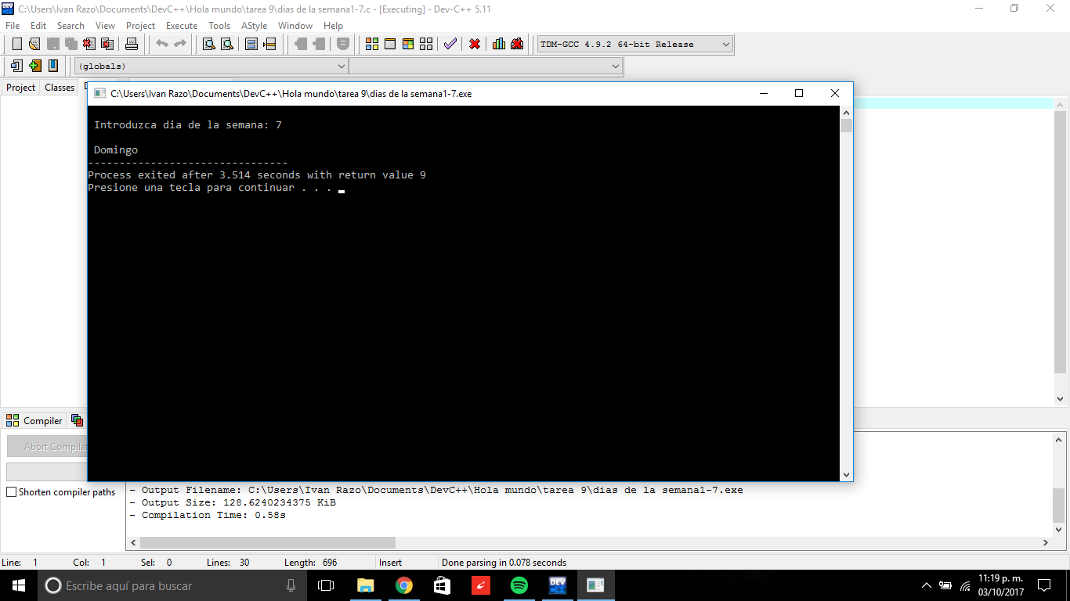

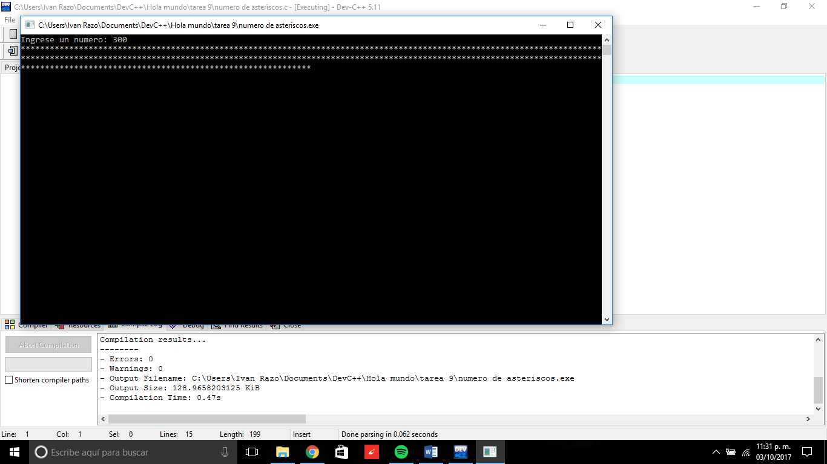

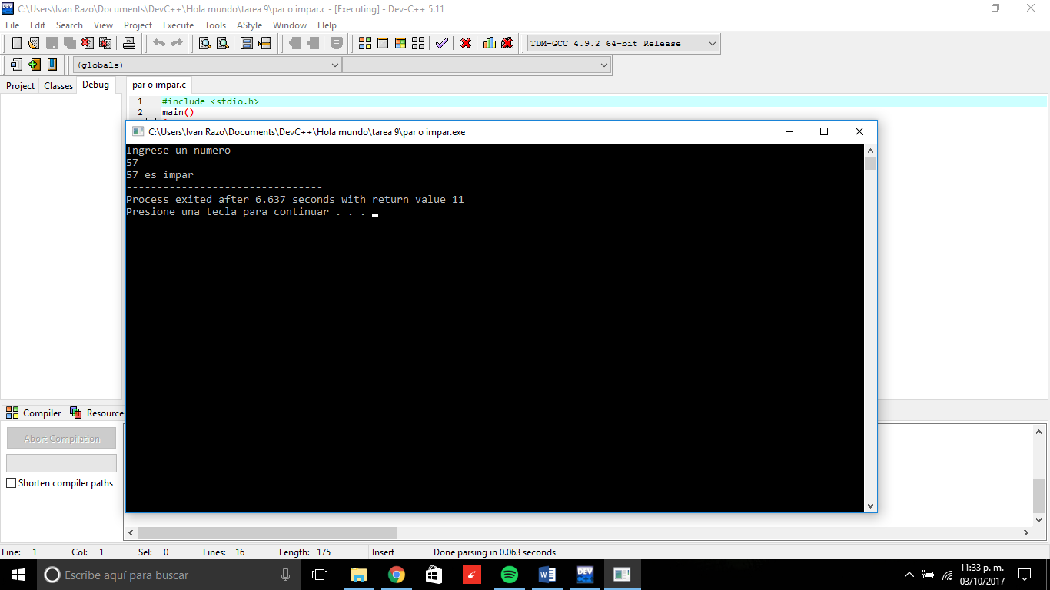

LINK: <https://github.com/EIRZ/Computadoras-y-Programaci-n-2018/tree/master/tarea%209>